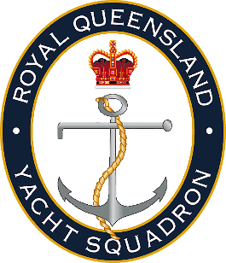

Request for Change of Division
To change Division, sailors must request a division change in advance (before the race day) by emailing this form to sailing@rqys.com.au or delivering it to the RQYS Sailing Office.
This form only applies to the 137th Sailing Season Off the Beach.
Note as per SI 19.2 If a skipper changes boat, classes or divisions, points for their season entry will remain with the boat, class / division they received these points in.

Boat Name
Sail Number
Skipper Name
Date for change to take effect
Current Division
New Division
Other Details

- Signed: …………………………. | - Date: …………….
  - Royal Queensland Yacht Squadron
  - sailing@rqys.com.au | 07 3396 8666
  - 578 Royal Esplanade, Manly, QLD, 4179

