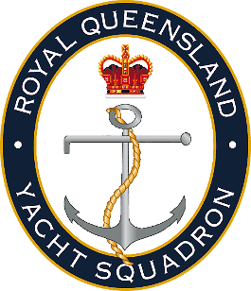

Request for Average Points
To receive average points, sailors must request average points in advance (before the applied race day/s) by emailing this form to sailing@rqys.com.au. Requests will be submitted to the Sailing Committee to be heard at the next Sailing Committee meeting.

Date
Boat Name
Sail Number
Skipper Name
Event Name
Event Date
Race Missed
Other Details

  - Royal Queensland Yacht Squadron
  - sailing@rqys.com.au | 07 3396 8666
  - 578 Royal Esplanade, Manly, QLD, 4179

